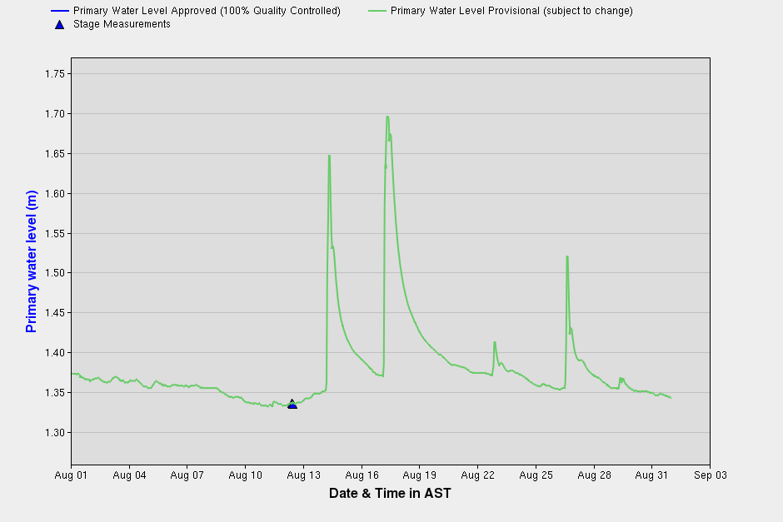
Real-Time Hydrometric Data Graph for LITTLE SACKVILLE RIVER AT MIDDLE SACKVILLE
Real Time Water Level Data for Sackville River

