Exploring the Mi’kmaq Culture with a Quillwork Inspired Craft
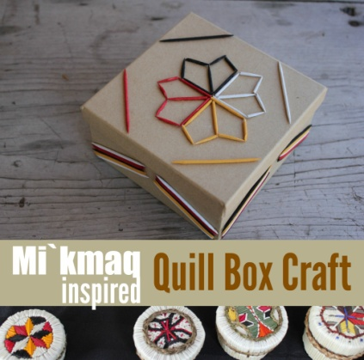
Birchbark Quill Boxes. Colorfully dyed quills are applied in geometric patterns, while natural quills are applied along the edges of the cover and the container. Porcupine quills, as seen below, are naturally white with black tips. Once removed from a hunted porcupine, the quills are cleaned, sorted by sized and then are used either naturally or dyed in various colors. Sometimes the quills need to be flattened and most often moistened prior to use.
Bin filled with porcupine quills
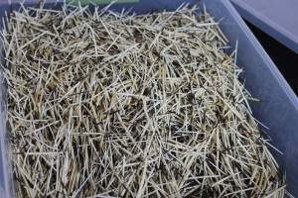
The artisans who we have seen continuing this traditional handicraft have been making birch bark quill boxes. The photo below shows the lid of a birch bark box being worked with quills. To insert the quills into decorative patterns, the bark is first perforated with an awl. The quills are threaded through the holes, and the moistened quills stiffen into place as they dry. The ends of the quills on the underside of the work are either folded over or snipped off, depending on how small the holes are and how tightly the quills are held.
A birch container’s cover with eight pointed star pattern in quillwork
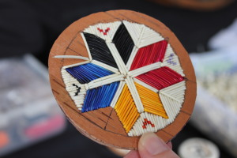
A common decorative pattern on birch bark boxes is the Mi’kmaq Eight Pointed Star. This star has been used for centuries as a symbol of the sun and has several meanings. Seven of the points represent the seven districts of the Mi’kmaq nation, while the eight was included in the 18th century to represent an alliance then established with Great Britain. The star also represents the four cardinal directions (North, South, East, West) and all those in between. The four colors, Red, Black, Yellow and White, represent the “four races of people”. When the star is made with the four colors, it represents togetherness and unity with all nations. It was a common symbol in 19th century quillwork, and continues to be popular in contemporary Mi’kmaq artwork and design.

Make a Mi’kmaq Quill Box Inspired Craft
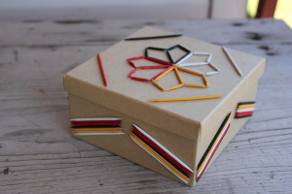

What you need:
- One box. The one we used is 6″ x 6″
- Toothpicks. To create the 8 pointed star pattern, you will need at least 16. Then it depends on what patterns you want to create. I recommend having extras just in case.
- Acrylic paint and paintbrush. Any color you’d like, but we used the 4 colors to represent the 4 nations: black, red, yellow and white.
- Clear drying white glue.

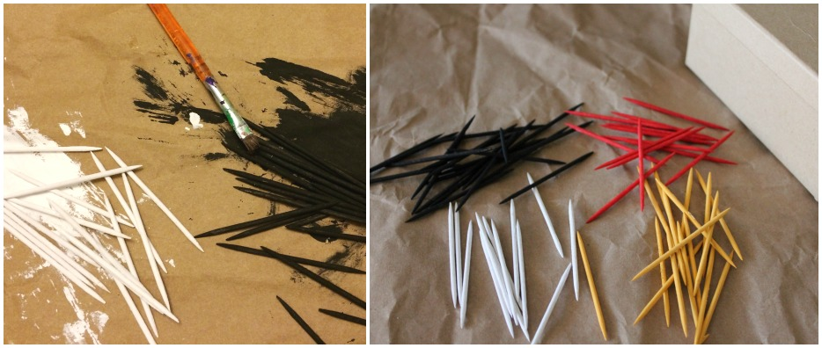
Directions:
You can start off by painting a bunch of toothpicks (what we did) and determine your pattern from there, or design first so you know how many toothpicks you’ll need. Be sure to paint a couple of extra toothpicks for each color, just in case. The wood absorbs the paint fairly quickly so they don’t take too long to dry. By the time we got to our fourth color, the first was dry.

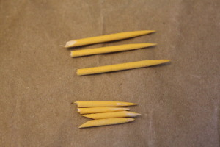
Prepare the toothpicks for the eight pointed star design. For each color (2 points of the star), you need 4 painted toothpicks. To “cut” them to size, we simply used our hands to bend and break them. They break rather easily, and you don’t need to be precise. With the four toothpicks of each color, break two in half and save the three best pieces. For the other two, break them in approximately three equal pieces. Save the four smaller pieces that turned out the nicest. Once “cut” to size, for each color you will want 3 longer pieces and 4 smaller pieces.
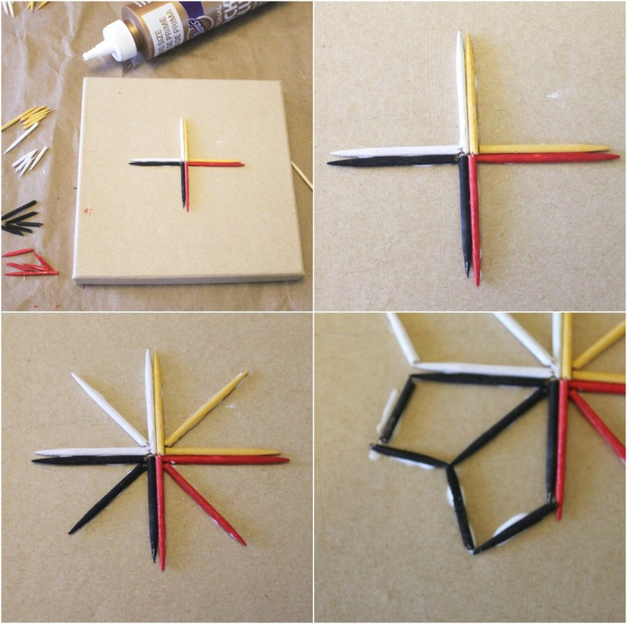
To make the eight pointed star design, start by creating a cross with four right angles using the longer pieces, as pictured below in the top images. To glue the toothpicks, run a bead of glue along the length of the stick. Then take the third longer piece and glue it diagonally in the center of each right angle, as pictured bottom left. Finish the points with the smaller pieces. I recommend placing two at a time first to align them, then glue them in place in order to get the angle right.
Create a design on the sides of the box. Be sure the toothpicks do not get in the way of the closed lid. With the striped pattern we did, rather than bead the glue along each toothpick, we only did it for the bottom stick and then dabbed glue on the box. The toothpicks were then placed on over the other in the glue. It’s easier than one at a time.
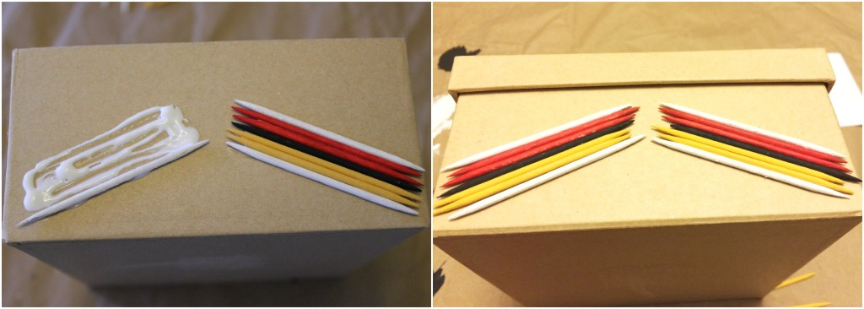http://multiculturalkidblogs.com/2014/11/06/exploring-the-mikmaq-culture-with-a-quillwork-inspired-craft-native-american-heritage-month-blog-hop/

