Name: ________________________________

Date: _________________________________

**Adaptations**

How have these plants adapted their seeds so they will scatter easily?

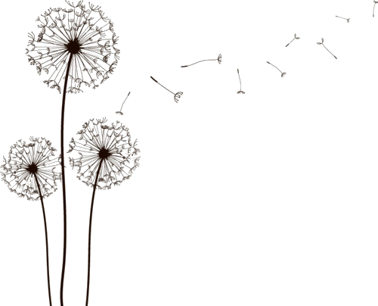

Dandelion

_________________________________________________________________________________________________________________________________________________________________________________________________________________________________________________________________________

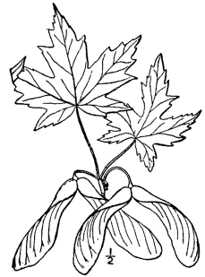

Maple

_________________________________________________________________________________________________________________________________________________________________________________________________________________________________________________________________________

C:\Users\Dell 2016\AppData\Local\Microsoft\Windows\Temporary Internet Files\Content.IE5\KH617ZE8\johnny-automatic-maple-seed[1].png

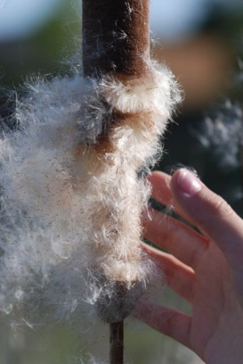

Cattail

_________________________________________________________________________________________________________________________________________________________________________________________________________________________________________________________________________

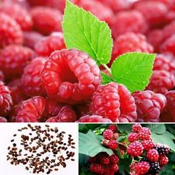

Raspberry

_________________________________________________________________________________________________________________________________________________________________________________________________________________________________________________________________________