Food Web
Name: ___________________
Date: ____________________
Construct a food web using the salmon food chains that you have already made.

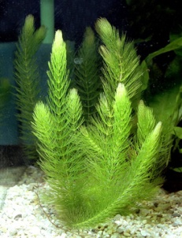
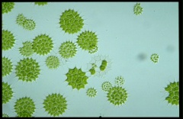
Water plants
algae

